***PAAREES PERFUMES***

***THIERRY MUGLER***

***FOR UNISEX***

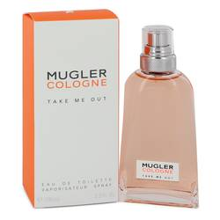

# 

# MUGLER TAKE ME OUT

## *Description:*

Mugler Take Me Out by Thierry Mugler Perfume. Released in 2018, Mugler Take Me Out is a unisex floral fragrance promising a fresh scent and an energizing experience. Its sleek glass bottle and orange packaging hints at the delightful contents within, with a blend consisting of only three notes but offering stunning complexity. Orange blossom lends brings clean, sweet, floral and bitter nuances, while shiso leaf adds peppery, fresh and somewhat minty undertones. The scent finishes with Mugler’s mysterious P note, which the brand says gives it an energetic twist for an out-of-this-world experience.